### 

### Semester One Examination, 2020

### Question/Answer booklet

# MATHEMATICS SPECIALIST

**UNIT 1**

## Section Two:

## Calculator-assumed

|  |  |
| --- | --- |
| **Your Name:** |  |
| **Your Teacher’s Name:** |  |

## Time allowed for this section

Reading time before commencing work: ten minutes

Working time: one hundred minutes

## Materials required/recommended for this section

***To be provided by the supervisor***

This Question/Answer booklet

Formula sheet (retained from Section One)

***To be provided by the candidate***

Standard items: pens (blue/black preferred), pencils (including coloured), sharpener, correction fluid/tape, eraser, ruler, highlighters

Special items: drawing instruments, templates, notes on two unfolded sheets of A4 paper, and up to three calculators approved for use in this examination

## Important note to candidates

No other items may be taken into the examination room. It is **your** responsibility to ensure that you do not have any unauthorised material. If you have any unauthorised material with you, hand it to the supervisor **before** reading any further.

|  |  |  |  |  |  |
| --- | --- | --- | --- | --- | --- |
| Question | Marks | Max | Question | Mark | Max |
| 8 |  | 9 | 15 |  | 8 |
| 9 |  | 4 | 16 |  | 7 |
| 10 |  | 6 | 17 |  | 10 |
| 11 |  | 8 | 18 |  | 10 |
| 12 |  | 10 | 19 |  | 11 |
| 13 |  | 7 |  |  |  |
| 14 |  | 9 |  |  |  |

**Structure of this paper**

|  |  |  |  |  |  |
| --- | --- | --- | --- | --- | --- |
| Section | Number of questions available | Number of questions to be answered | Working time (minutes) | Marks available | Percentage of examination |
| Section One:  Calculator-free | 7 | 7 | 50 | 46 | 35 |
| Section Two:  Calculator-assumed | 12 | 12 | 100 | 100 | 65 |
|  |  |  |  | **Total** | 100 |

**Instructions to candidates**

1. The rules for the conduct of the Western Australian Certificate of Education ATAR course examinations are detailed in the *Year 11 Information Handbook 2019*. Sitting this examination implies that you agree to abide by these rules.
2. Write your answers in this Question/Answer booklet.
3. You must be careful to confine your answers to the specific questions asked and to follow any instructions that are specific to a particular question.
4. Additional pages for the use of planning your answer to a question or continuing your answer to a question have been provided at the end of this Question/Answer booklet. If you use the space to continue an answer, indicate in the original answer space where the answer is continued, i.e. give the page number.
5. **Show all your working clearly.**Your working should be in sufficient detail to allow your answers to be checked readily and for marks to be awarded for reasoning. Incorrect answers given without supporting reasoning cannot be allocated any marks. For any question or part question worth more than two marks, valid working or justification is required to receive full marks. If you repeat any question, ensure that you cancel the answer you do not wish to have marked.
6. It is recommended that you **do not use pencil**, except in diagrams.
7. The Formula sheet is **not** to be handed in with your Question/Answer booklet.

**Section Two: Calculator-assumed (100 Marks)**

This section has **twelve** questions. Answer **all** questions. Write your answers in the spaces provided.

Spare pages are included at the end of this booklet. They can be used for planning your responses and/or as additional space if required to continue an answer.

● Planning: If you use the spare pages for planning, indicate this clearly at the top of the page.

● Continuing an answer: If you need to use the space to continue an answer, indicate in the original answer space where the answer is continued, i.e. give the page number. Fill in the number of the question that you are continuing to answer at the top of the page.

Working time: 100 minutes.

**Question 8** {1.3.7, 1.3.9, 1.3.11, 1,3,15} **(9 marks)**

Point $O$ is the centre of the circle below, and $\overline{CD}$ is tangent to the circle.

For each of the angle sizes indicated below, fill in the table.

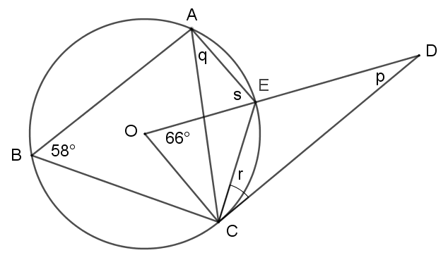

|  |  |  |
| --- | --- | --- |
|  | Size | Reason |
| $$p$$ |  |  |
| $$q$$ |  |  |
| $$r$$ |  |  |
| $$s$$ |  |  |

**Question 9** {1.3.8, 1.3.12} **(4 marks)**

In the diagram on the right, $\overline{AY}$ bisects $∠BAC$.

1. Prove that $ΔABX$ is similar to $ΔCYX$. (2 marks)

1. Hence, prove that $ΔAYC$ is similar to $ΔCYX$. (2 marks)

**Question 10** {1.2.14} **(6 marks)**

At 8pm, a lighthouse detects a ship at a position of $4i-7j km$.

1. If the ship is travelling at $i+2j km/h$, express its position $t$ hours after 8pm.

(1 mark)

1. At what time is the ship closest to the lighthouse? (3 marks)
2. Hence, what is the closest distance the ship is from the lighthouse? (2 marks)

**Question 11** {1.2.8, 1.2.9} **(8 marks)**

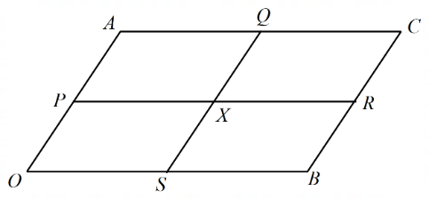Let $OACB$ be a parallelogram, and let $a=\vec{OA}$ and $b=\vec{OB}$. Let $P,Q,R$ and $S$ be the midpoints of $\overline{OA}$, $\overline{AC}$, $\overline{CB}$ and $\overline{OB}$ respectively, and let $X$ be the point of intersection of $\overline{PR}$ and $\overline{QS}$.

1. Let $M$ be the midpoint of $\overline{SQ}$. **Show** that $\vec{OM}=\frac{1}{2}a+\frac{1}{2}b.$ (2 marks)
2. Let $N$ be the midpoint of $\overline{PR}$. Determine an expression, in terms of $a$ and $b$, for $\vec{ON}$.

(1 mark)

1. Explain why $\vec{OX}=\vec{OM}$. (2 marks)
2. Hence, prove that $OPXS$ is a parallelogram. (3 marks)

**Question 12** {1.2.11, 1.2.12} **(10 marks)**

A circle has centre $O$ at the origin. Point $A$ on the circle has position vector $\vec{OA}=ai+bj$, and point $B$ on the circle has position vector $\vec{OB}=bi-aj$, where $a$ and $b$ are real constants. Point $C$ (outside the circle) has position vector $\vec{OC}=34i+14j$.

1. Determine expressions for each of the vectors $\vec{AC}$ and $\vec{BC}$. (3 marks)
2. Hence determine expressions for each of $\vec{AC}⋅\vec{OA}$ and $\vec{BC}⋅\vec{OB}$. (3 marks)
3. Given that $\overset{⃡}{AC}$ and $\overset{⃡}{BC}$ are both tangent to the circle, and the radius of the circle is 26, determine the values of $a$ and $b$.

(4 marks)

**Question 13** {1.1.1-1.1.4} **(7 marks)**

The 10 letters of the word

O P A P O P A P O P

are written on 10 separate pieces of card. These cards are arranged in a line next to each other.

1. How many different word arrangements (of length 10) can be made? (2 marks)

1. How many arrangements start and end with P? (2 marks)

1. The ten letters are arranged in a random order. Determine the probability that the resulting arrangement will start and finish with the same letter.

(3 marks)

**Question 14** {1.1.1-1.1.5} **(9 marks)**

The nine single digit numbers are written on nine separate pieces of card.

1, 2, 3, 4, 5, 6, 7, 8, 9

Four of these cards are picked at random and placed next to each other to form a four digit number.

Determine the probability that the four-digit number will be formed with the given conditions:

1. has both odd and even digits. (3 marks)
2. the number has at least three odd digits. (3 marks)

1. the sum of the four digits is 28.

(3 marks)

**Question 15** {1.1.6, 1.1.7, 1.1.8} **(8 marks)**

1. How many 8-character passwords can be generated using the symbols ***!@#$%^&\****
2. if the first three symbols must be ***$&@*** (in any order) and the next two symbols must be ***^\**** (in any order)? (2 marks)

1. if the order of ***!#%&*** cannot be changed, but their placement may be changed? (e.g. ***!#%&***@$^* and @$***!#***^\****%*&** are acceptable, but **&*#%!***@$^&* and @$***%!***^\***&*#*** are not)

(3 marks)

1. Year 7 students at Perth Modern School were asked to write a password generator in Python with a mix of lowercase letters, uppercase letters, whole numbers, and symbols from (a). Each password must have length six. **Prove** that at least one character will be used more than once within 12 generated passwords. (3 marks)

**Question 16** {1.1.7, 1.1.8} **(9 marks)**

A team of six students is to be selected for a Mathematics competition from ten Year 11 and eight Year 12 students. How many different teams are possible if:

1. there are no restrictions. (2 marks)
2. there must be exactly 3 Year 11 students and 3 Year 12 students. (2 marks)
3. there must be at least 2 Year 11 students and at least 2 Year 12 students. (3 marks)
4. one student in the team is assigned to the role of captain, and another student to the role of vice-captain, and there are no other restrictions. (Note that teams consisting of the same students count as distinct if the roles of captain and/or vice-captain are assigned differently). (2 marks)

**Question 17** {1.2.1 – 1.2.5}**(10 marks)**

1. In the diagram below, $M$ is the midpoint of $AB$, $a=\vec{CA}$ and $b=\vec{CB}$. Given that $CP:PM=3:2$, determine the value for $λ$ if $\vec{CN}=λ\vec{CB}.$ (5 marks)

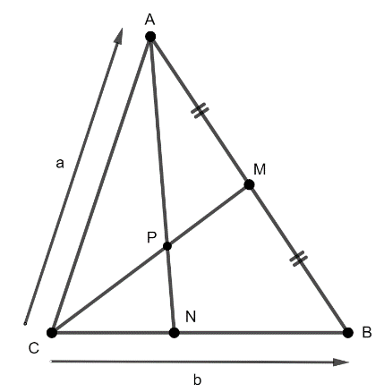



1. Let $c=\left[\begin{matrix}k-1 \\ 6\end{matrix}\right]$ and $d=\left[\begin{matrix}-1 \\ k+1\end{matrix}\right]$. Find the value of $k$, if $\left|d-c\right|=\frac{k(c∙d)}{5k+7}$. (5 marks)

**Question 18** {1.2.6 – 1.2.9} **(9 marks)**

Elizabeth Quay Jetty (Point E) and Mends St Jetty (Point M) are such that $\vec{EM}=(-335i-1287j)$ m. A yacht is to be sailed from E to M. In still water, the yacht can maintain a steady speed of 3.2 m/s. The wind is blowing with a steady velocity $3i-j.$

1. Find, in the form $ai+bj$, the velocity vector the sailor should set so that the yacht can travel from E to M. (7 marks)

1. Determine, to the nearest minute, the time the yacht takes to travel from Elizabeth Quay Jetty to Mends St Jetty. (2 marks)

**Question 19** {1.2.10 – 1.2.13} **(11 marks)**

If $r=2i-j$, $s=xi-4j$**, $t=-3i+4j$** , and $u=i-8j$ determine

1. the value of $x$ such that $r⊥s$. (2 mark)
2. the angle between the directions of $s$ and $t$ to the nearest tenth of a degree (using the value of $x$ found in part (a)). (2 marks)
3. the unit vector in the direction of $u$. (2 marks)

1. the vector projection (i.e. the vector resolute) of $t$ on $u$. (2 marks)
2. the area of triangle that vectors $s$**, $t$** , and $u$ form by drawing a diagram with all the given vectors (3 marks)

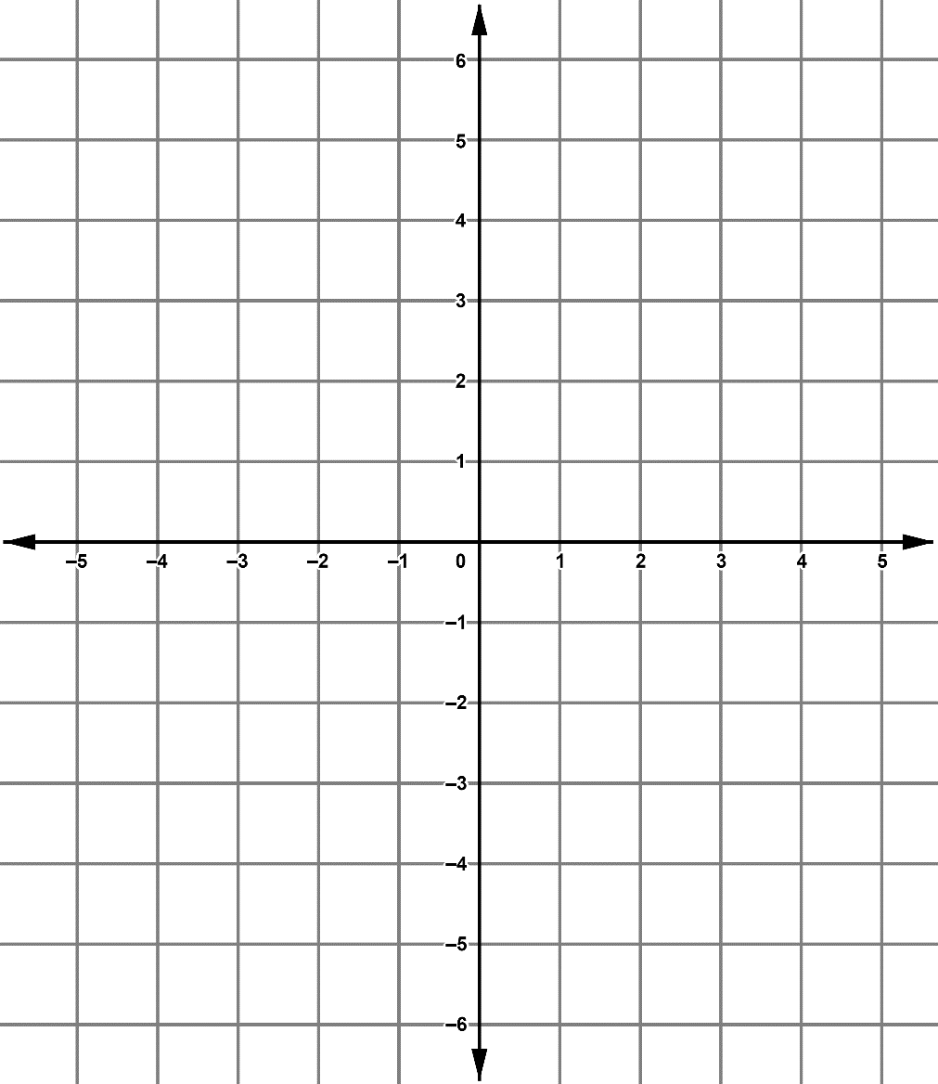

Additional working space

Question number: _______

Additional working space

Question number: ________

Additional working space

Question number: ________